Renju lesson on May 23, 2002

Hello everyone! Welcome to Online Renju Class. Today is our 2nd birthday, eh? Who agrees with that, press I am here. :) Wow, everybody agreed today is the birthday! :) I am so happy that so many people came here today! :) I do not have long speech today. I just want to thank all of you for helping the class and being a great community throughout the year! You have a great job and Renjuclass has fulfilled its purpose. I thank all the helpers, especially luwenzhe, Volodymyr, ladykayak, farmer, gawa, and many others. I also thank our advanced students who have played well in tournaments recently and proven a good quality and reputation of the class. And thanks again to namic_99 and ladykayak for helping me getting started with Renjuclass. About my plans... We are about to begin the 3rd year. How many of you are willing to be serious students within coming year?

<span> me
<pantrike> me
<span> :)
<shuwang> me
<Rehnstedt> me :o)
<civsnail> me
<Beckham_Tang> i am
<tunnet99> me
<moocheng> me
<zemeban> me
<ladykayak> I hope so
<shadewawa> me
<5345744> I will try my best~~~
<angelwawa> i
<yyfcsd> me
<yusuke_o> I am :)
<ASV777> i hope i can study serious..
<Guest503> May i?
<Liuchao> try my best:)
<concord2497> I hope so too
<keresztespok> I should give more time to renju
<yangxuzl> me
<guminzhao> I
<luwenzhe> me
<scm2000> me
<Guest489> i hope i can join the class too
<ladykayak> I am thinking we need to make the teacher work harder
<Guest501> me too
<yun_shou> me
<Guest479> I hope too

So many serious and interested students. I guess I do not have much choice here. I have been outvoted. Therefore, I will have to prepare for our third year of study. The third year will include: We will complete the study of all openings. Maybe within 6-8 months. We will also go on with our War of Roses project and make it happen. Besides, we will play the 3rd Renjuclass Tournament.
Just as last summer, we cannot be sure about the schedule of lessons. Probably we will decide each month in last minute. Thank you all again, and may we all have a successful 3rd year! Thanks! Do you know what will happen today? At first I was going to delete all 14 grand masters from student list, but in second thought I decided we'd better have a match Teacher vs Students. Before we begin with match, we need to see who is awake. wow, ladykayak, keres and lu are so fast! First, we need a volunteer for making moves for Students team. Who? Lu will make moves, and span will get the other job - to count votes. We need the third volunteer, to push people to speed up and let them know when time is up.
It is a party game, not a serious match. :)
So, who will be time refree?
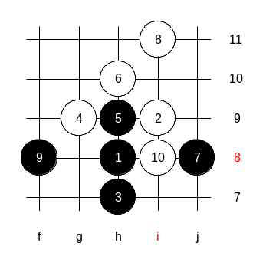
Just need to announce that voting begins and voting ends. and span will count votes after that and lu makes a move. About the opening, As a tradition, I set up the opening pattern. This time, it appears to be black sure win pattern. Students will be Black. See the 4 stones on the board. There should be two 5th moves, but for the simplicity, we skip 5-i8 (5-g8), so you just offer the 2nd 5th move. Do you understand the rules? luwenzhe, span, Beckham ready?
Here we go!
RT is getting worried. :)

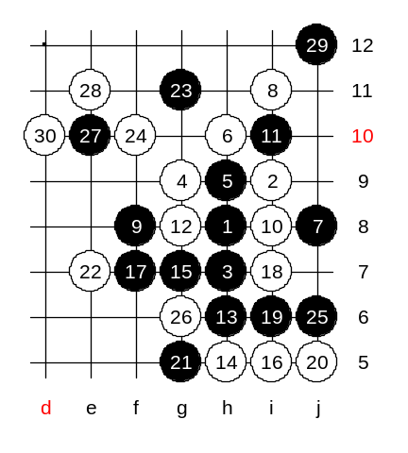
Wow, nice teamwork guys!
Beckham is counting the time well. Keep going, guys!
Hard to choose 22nd move. Had to use up all my time.
Wow, so many students disconnected. We need to wait until they return. Including beckham.
I play safe 28. After the 30th move,
<tunnet99> why didn't we play d10 four first??

The 33rd move,
<luwenzhe> beck, you count too fast!!!!!!!!!!!!!
<Beckham_Tang> if we have 5 tunnets we will win. do we really have 5 tunnets ? no .. so we cant win...
<keresztespok> we are going down ;-(

Come on guys, keep up your fighting spirit! :))
Move 61-i3 loses. Please re-play that move and vote again.
Please re-vote 65-g4. Else wins with 4x4.
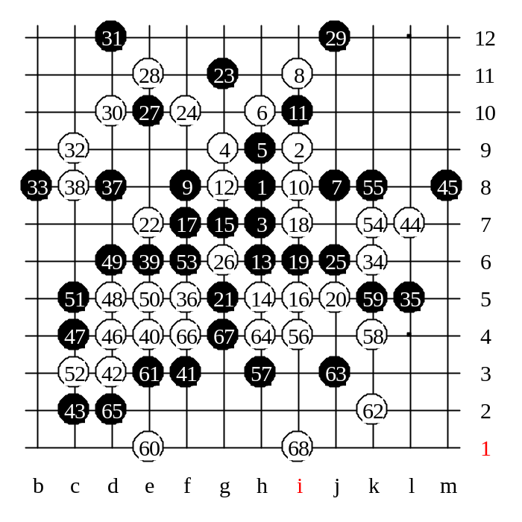
Thanks for good fight! The Students team was really good! It seems the 55th move was the weakest one in this game. Maybe 55-k5 can do. We have finished the lesson now. We learned a new 4th move today. I guess this 4th move needs some comments next week, right? We realized that the theoretical 5th move ends up with a problematic situation. That is a fact, and not your fault. And before we leave today, I announce the credit points. Today, as promised, whose name appears in the list below, gets 2 cp. Congratulations!

